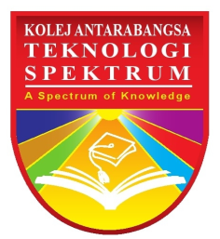

**KOLEJ ANTARABANGSA TEKNOLOGI SPEKTRUM  
TIME TABLE**

**DIPLOMA IN MANAGEMENT / DIPLOMA IN RENEWABLE ENERGY MANAGEMENT / ATHE**

# **B0619 (8)**

|  |  |  |  |  |  |
| --- | --- | --- | --- | --- | --- |
| **DATE**  **TIME** | **9.30 – 11.00** | **11.00 – 12.30** | **12.30 – 2.00** | **2.00 – 3.30** | **3.30 – 5.00** |
| Monday |  | Principle of Management  Ms Aini  **SEG 1** | **B** |  |  |
| Tuesday |  | Principle of Management  Ms Aini  **SEG 1** | **R** | Pengajian Malaysia  Ms. Suwarnee  **SEG 2** | Pengajian Malaysia  Ms. Suwarnee  **SEG 2** |
| Wednesday | English Proficiency  Ms. Nageena **SEG 2** | English Proficiency  Ms. Nageena **SEG 2** | **E** | Pengajian Malaysia  Ms. Suwarnee  **SEG 2** | Pengajian Malaysia  Ms. Suwarnee  **SEG 2** |
| Thursday | Principle of Management  Ms Aini   **SEG 2** | Principle of Management  Ms Aini   **SEG 2** | **A** | English Proficiency  Ms. Nageena  **SEG 2** | English Proficiency  Ms. Nageena  **SEG 2** |
| Friday |  |  | **K** |  |  |